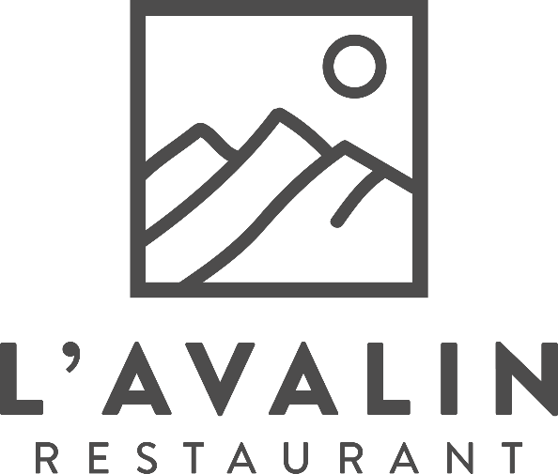

Welcome, It is with great pleasure and a warm Alpine welcome that we introduce you to our new restaurant, L’Avalin.

The term “Avalin” in French means to originate from Val d’Isère.

The camaraderie between our team, our community and our cherished customers along with our passion for food is what makes us L’Avalin.

Nevertheless, the story behind L’Avalin started long before we opened our doors in the “Gallerie des Cimes”. Oliver, the owner, moved to Val d’Isère at the age of 18 and fell in love with the resort and it quickly became apparent it was his home …

Oliver & L’Avalin team

***Our starters***

**The panko prawns** x5 18€

Crispy and tasty, perfect as an aperitif

Coated in Japanese breadcrumbs served with a sweet chili sauce



**The vegetable arancini** x3 16€

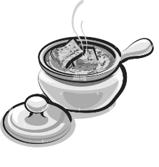A pleasant contrast between a crispy crust and a soft rice centre

Served on crushed tomatoes



**The traditional French onion soup** 15€

A comforting French classic, ideal for alpine evenings



**The mushroom velouté & poached egg** 15€

Served with roasted hazelnuts & croutons

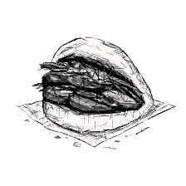**The pulled pork Bao buns** x3 16€

A delicious fusion of Asian & American cuisine

**The red tuna tataki** 23€

Served on crunchy vegetables marinated in sesame oil, mint and coriander

Finished with pomegranate, wakame & wasabi mayonnaise

**The charcuterie board** 18€

A variety of cold meats selected by our chef Hugo

Served with gherkins & pickles

**The homemade foie gras** 26€

A refined French dish

Served with pineapple chutney, toast & a touch of salt

***Our main courses***

**The Italian style beef tartare** 28€

A classic from our old restaurant La Source

Prepared by our chef Claudiu, garnished with sundried tomatoes, olives, pesto & parmesan

Served with fries & salad

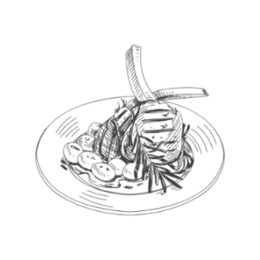**The rack of lamb roasted with thyme** 32€

This classic French dish highlights the tenderness & rich flavours of lamb

Served with dauphinois potatoes & a garlic jus

**The authentic beef burger**26€

Crazy Barmes’ bun filled with a fresh beef patty, red onion confit, raclette cheese,

homemade mayonnaise, salad & tomatoes

Served with fries & salad

**The crispy chicken burger** 26€

Crazy Barmes’ bun filled with chicken fillets coated in cornflakes, red onion confit,

raclette cheese, homemade mayonnaise, salad & tomatoes

Served with fries & salad

**The Simmental ribeye steak** 36€

A cut of meat renowned for its tenderness & flavour

Served with a choice of either dauphinois potatoes / sweet potato puree / fries / salad

And a choice of peppercorn sauce or morel mushroom sauce

**The poke bowl**

The Hawaiian dish, a healthy and aromatic option, ideal for a balanced meal,

with a choice of:

* Fresh red tuna served mi-cuit 29€
* ******Chicken fillets coated in cornflakes 27€
* Vegetarian option 26€

Served with fragrant rice, crunchy vegetables & a sesame vinaigrette

***Our fish and vegetarian***

**The fillet of sea bass**  29€

A white & delicate fillet, carefully deboned

Served with sweet potato puree, green vegetables & a citrus sauce



**The vegetable curry** 28€

A blend of spicy & slightly sweet flavours

The chickpeas, array of vegetables and coconut milk make this dish a meal for everyone

Served with basmati rice & a naan bread

***To share***

**The prime ribeye steak** 42€/pp

A beautiful grilled piece of beef to share with friends

Minimum 36 oz / 1 kg

Served with a choice per person of dauphinois potatoes / sweet potato puree / fries or salad

With peppercorn sauce & morel mushroom sauce

**The traditional cheese fondue**  29€/pp

Our timeless mountain dish

Our fondue is a blend of Abondance, Beaufort & Comté cheese

Served with salad

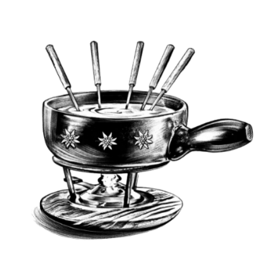

**The porcini mushroom cheese fondue** 32€/pp

Our forestry twist

Served with salad

**The raclette** 31€/pp

The emblematic dish of Alpine cuisine

Served with cold meats, charlotte baby potatoes & salad

To accompany your fondues, our selection of cold meats board is €12 for two people

***Our desserts - from the kitchen***

**The lemon tart** 12€

Individual!

A lemon & white chocolate filling – served on a Breton shortbread biscuit



**The creme brulee** 11€

Classic!

Prepared with Bourbon vanilla & glazed with brown sugar

**The « Bolet de Solaise »** 11€

From La Grande Ourse to La Source to L’Avalin

A vanilla ice cream & meringue dome, covered with melting hot chocolate

**The chocolate lava cake** 11€

Childhood!

Served with a soft melting centre & vanilla ice cream

**The cheese board**  14€

A selection of three cheeses from our local farm in Val d’Isère

Valiflette, half-goat half-cow Tomme & Beaufort

**The Greek yogurt from « La ferme de l’adroit »** 9€

Served with a choice of blueberry compote, honey or sugar

**The ice cream & sorbet**

Ice cream flavours: vanilla, chocolate, yogurt, salted caramel 2 scoops: 6€

Sorbet flavours: strawberry, lemon, mango 3 scoops: 8€

***Our desserts - from the bar***

**The Irish coffee** 14€

Jameson whiskey, cane sugar & homemade whipped cream with Baileys

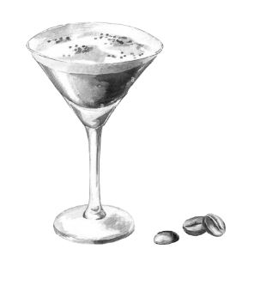**The espresso martini** 14€

Vodka Smirnoff, an espresso, vanilla syrup & coffee liqueur

**The pornstar martini** 14€

Absolut Smirnoff, passion fruit puree, vanilla sirup & lime juice

**Le génépi traditionnel des pères chartreux** 2cl : 5€ 4cl : 9€

To develop their recipe, the Carthusians call on different producers in the Alps who select for them the best varieties of Artemisia, with an alcohol level of 40°

Served neat or on the rocks

**The chartreuse green or yellow** 2cl: 6€ 4cl: 12€

The green one offers intense herbaceous aromas with an alcohol level of 55°

The yellow is softer with delicate flower aromas with an alcohol level of 43°

Served neat or on the rocks

**The chartreuse elixir liqueur** 2cl: 8€ 4cl: 14€

To create this blended liqueur, the Carthusians used all their know-how

and the knowledge to select liqueurs reminiscent of aromatic power

vegetable elixir, with an alcohol content of 56°

Served neat or on the rocks

**The chartreuse MOF** 2cl: 8€ 4cl: 14€

The MOF, created in tribute to the “Meilleurs Ouvriers de France”, produced in small

quantities, offering a complex and refined aromatic profile, with an alcohol level of 45°

Served neat or on the rocks

**The chartreuse 9th centennial** 2cl: 10€ 4cl: 18€

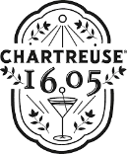This special vintage was created for the first time in 1984 by the Carthusian fathers to commemorate the 900th anniversary of the founding of the Carthusian Order in 1084 by Saint Bruno, with an alcohol content of 47°

Served neat or on the rocks

***our children’s menu* < 12 years old**

**little Avalin’s, you’re in charge!**

**Step 1: choose your protein**

Chicken fillets coated in cornflakes

Fresh beef patty

Vegetable curry

**Step 2: choose your side**

Fries

Sweet potato puree

Basmati rice

Salad

**Step 3: choose your dessert**

A scoop of ice cream or sorbet

An apple compote

15€



*Price and service included*